**Existing Systems**

Set of words search (for example : new bestselling science fiction books)

**Google Search :**

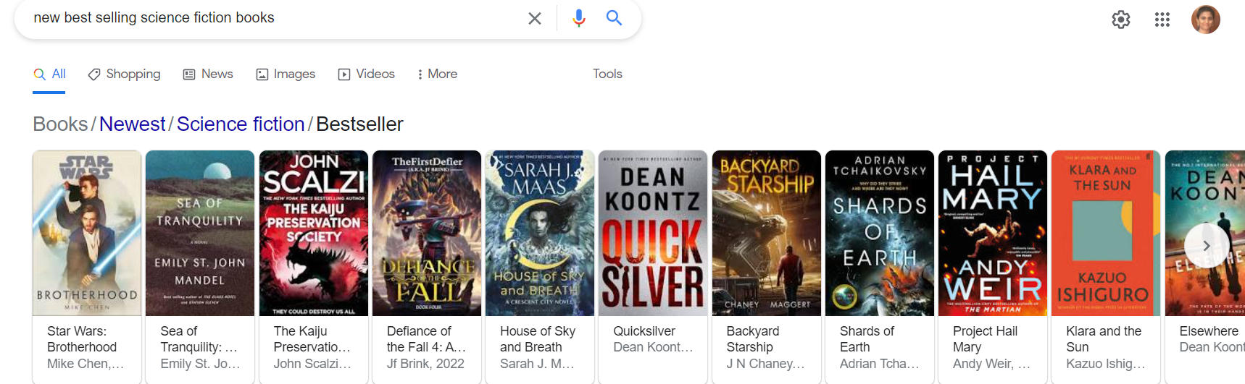

**Amazon Search :**

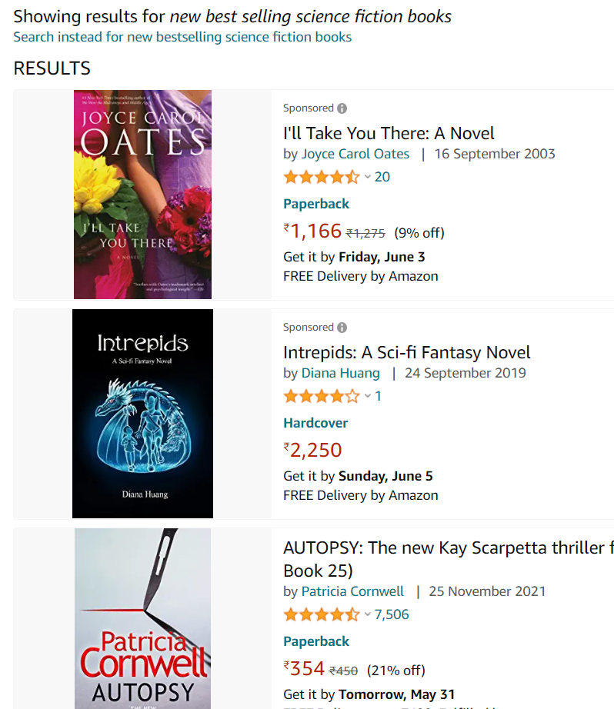

**Advantage over existing system :**

**Both these systems give recommendation based on the user ratings, but our system gives recommendation based on the positivity, neutrality and negativity based on the feedback given by the previous users.**

**Existing System**

Single keyword search (for example : good)

**Amazon Search**

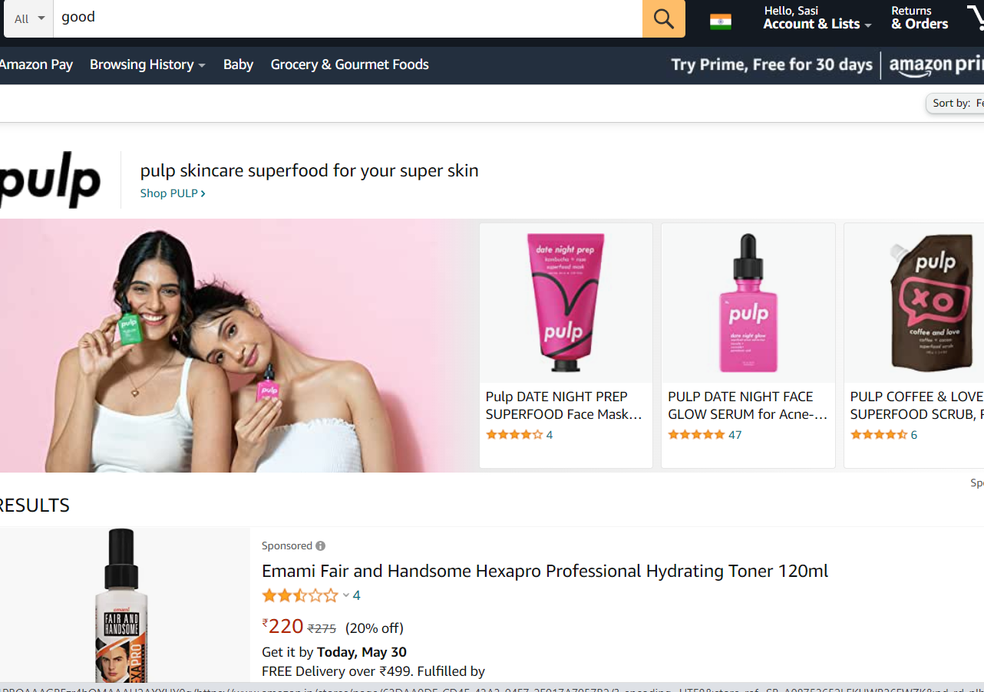

**Existing system**

**Google Search:**

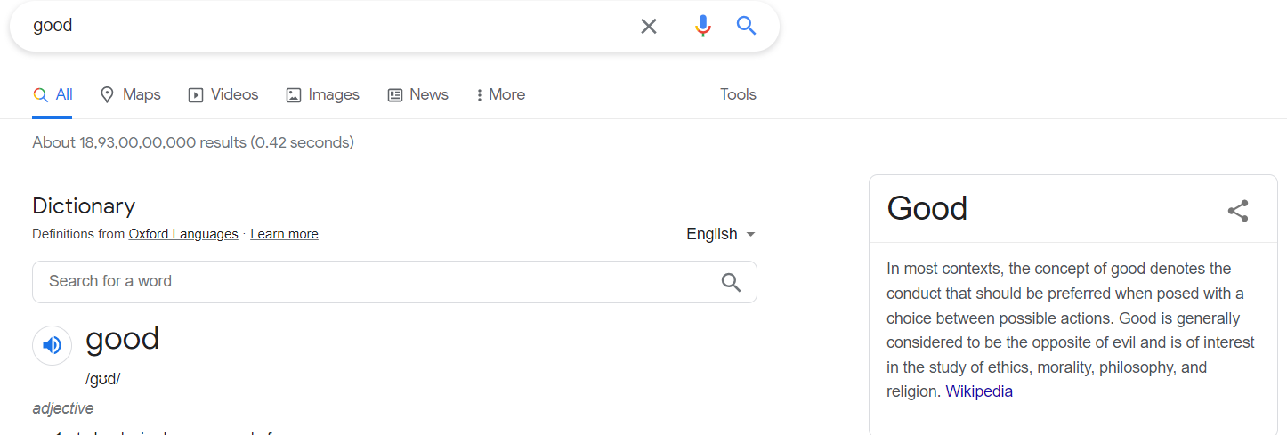

**Advantage over existing system :**

**Both the systems give recommendations based on the word good, they give random products, but our system gives the recommendation to only books which contains the description or the summary of the book included in that word.**